Project Planning Phase
Project Planning Template (Product Backlog, Sprint Planning, Stories, Story points)

Date | 4 july 2026
Team ID
Project Name | Book Store project
Maximum Marks | 5 Marks

Product Backlog, Sprint Schedule, and Estimation (4 Marks)
Use the below template to create product backlog and sprint schedule
Sprint | Functional Requirement (Epic) | User Story Number | User Story / Task | Story Points | Priority | Team Members
Sprint-1 | Registration | USN-1 | As a user, I can register for the application by entering my email, password, and confirming my password. | 2 | High | B.Farheen
Sprint -1 | Book catlog | USN-2 | AS a user I can view the list of available books | 2 | High | sohail
Sprint-1 | Search books | USN-3 | AS a user I can search books by titles | 1 | High | keerti
Sprint-1 | Check out | USN-5 | As a user, I can place an order for selected books | 2 | Medium | Farheen

Project Tracker, Velocity & Burndown Chart: (4 Marks)
Sprint | Total Story Points | Duration | Sprint Start Date | Sprint End Date (Planned) | Story Points Completed (as on Planned End Date) | Sprint Release Date (Actual)
Sprint-1 | 20 | 6 Days | 2 june 2026 | 6 june2026 | 20 | 12 june2026
Sprint-2 | 20 | 6 Days | 7 june 2026 | 10june 2026 | 8 | 18 june 2026
Sprint-3 | 20 | 6 Days | 18 june 2026 | 25 june 2026 | 8 | 25 june2026
Sprint-4 | 20 | 6 Days | 27 june 2026 | 30 june 2026 | 8 | 01 july2026

Velocity:
Imagine we have a 10-day sprint duration, and the velocity of the team is 20 (points per sprint). Let’s calculate the team’s average velocity (AV) per iteration unit (story points per day)


Burndown Chart:
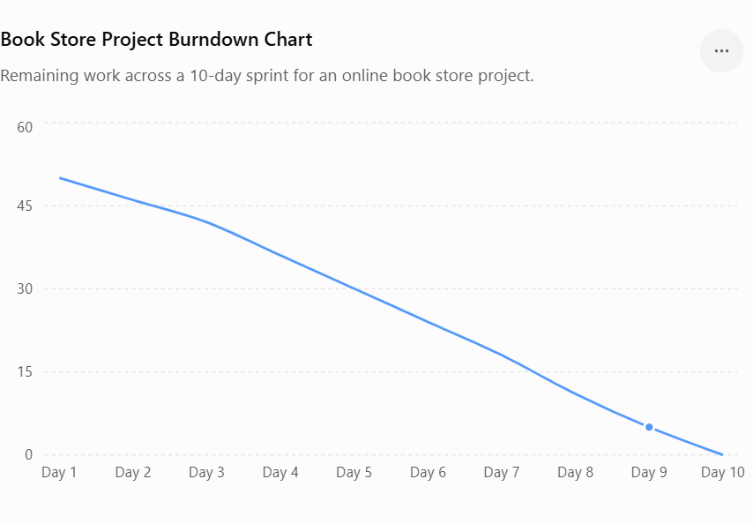

A burn down chart is a graphical representation of work left to do versus time. It is often used in agile software development methodologies such as Scrum. However, burn down charts can be applied to any project containing measurable progress over time.

https://www.visual-paradigm.com/scrum/scrum-burndown-chart/
https://www.atlassian.com/agile/tutorials/burndown-charts

Reference:
https://www.atlassian.com/agile/project-management
https://www.atlassian.com/agile/tutorials/how-to-do-scrum-with-jira-software
https://www.atlassian.com/agile/tutorials/epics
https://www.atlassian.com/agile/tutorials/sprints
https://www.atlassian.com/agile/project-management/estimation
https://www.atlassian.com/agile/tutorials/burndown-charts

